A priority queue for a simplified agenda manager in a rule-based expert system shell



Abhishek Kumar

R#11416761

**Table of Contents**

1. Objective

2. Background

3. Program Description

4. Instructions to execute the program

5. Test Results

5.1 Input File: test1.txt

5.2 Input File: test2.txt

5.3 Input File: test3.txt

**1. Objective**

To create an application of priority queue for a simplified agenda manager in a rule-based expert system shell by using the concepts of heap. The agenda manager application should take an input file from the user and extract the highest priority rule after each cycle is executed.

**2. Background**

The two basic elements of a rule-based expert system shell are a knowledge base and an inference engine. The knowledge base contains the domain knowledge in the form of rules. The inference engine uses these rules to produce a solution to a given problem. The inference engine operates in cycles. In each cycle, it first determines which rules can be activated for firing (called activated rules), then selects one rule for execution and finally executes the selected rule.

Each activated rule has a corresponding priority. An agenda contains a list of activated rules, with their priorities, maintained by an agenda manager. In each cycle, an agenda manager updates list of activated rules by adding new activated rules and deleting rules that are no longer activated and the rule that was executed in a previous cycle.

**3. Program Description**

The program gets its input file from the user. Once the user provides the filepath, file is obtained & started process each line of the input file. The first line will be read & parses the names of the rule & priority value. After the whole line is read, a heap will be built using buildHeap() & heapify() methods. After building the heap, the higher priority rule will be found out & displayed as output through extractMax () method. The displayed element will be removed from the heap.

Similarly rules present in further lines of input file will be added into the heap built. At the end of adding all elements in each line of input file, the highest priority rule will be displayed. After the input file is fully read, the rules will be displayed as per the highest priority until all the rules are processed.

**4. Instructions to execute the program**

Step 1: Save the input files (test1.txt, test2.txt, test3.txt) in the same location as the source code.

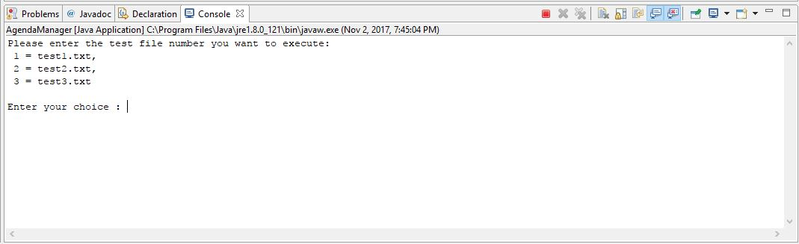Step 2: Run the program using any IDE (Eclipse).

Step 3: The results for the given choice will be printed in the console.

**Test Results**

**5.1 Input file: test1.txt**

Given below is the link of the input file – test1.txt that is being executed to call the priority queue for a simplified Agenda Manager.

[Click here](https://github.com/abhishek-kumar-code/AgendaManager/blob/master/src/test1.txt)

<https://github.com/abhishek-kumar-code/AgendaManager/blob/master/src/test1.txt>

